Post Event Summary Report

| Event | ALiAS Summer of Code |
| --- | --- |
| Speakers | – |
| Date | September - October 2023 |
| Venue | Online |
| Timings | – |

Overview:

ALiAS Summer of Code was a month-long program where students from in and outside Amity were onboarded for mentorship under experienced mentors to work on ALiAS’s own open source projects and others.

The aim of this program is to prepare students for prestigious open source programs like Google Summer of Code, Outreachy, MLH fellowship etc.

The program was officially supported by the FOSS United Foundation, backed by Zerodha.

The program included an offline talk during the ALiAS Kickstart event and PyDelhi conference, then interested mentees created and submitted a project proposal for the project they wanted to contribute to.

The project list included:

1. Amibot whatsapp

2. Amibot Discord

3. Amibot Telegram

4. ALiAS Website

5. Amiverse

6. Interpreted

7. Sahl

8. Bfportal

9. PixelblasterOS

10. Box CLI Maker

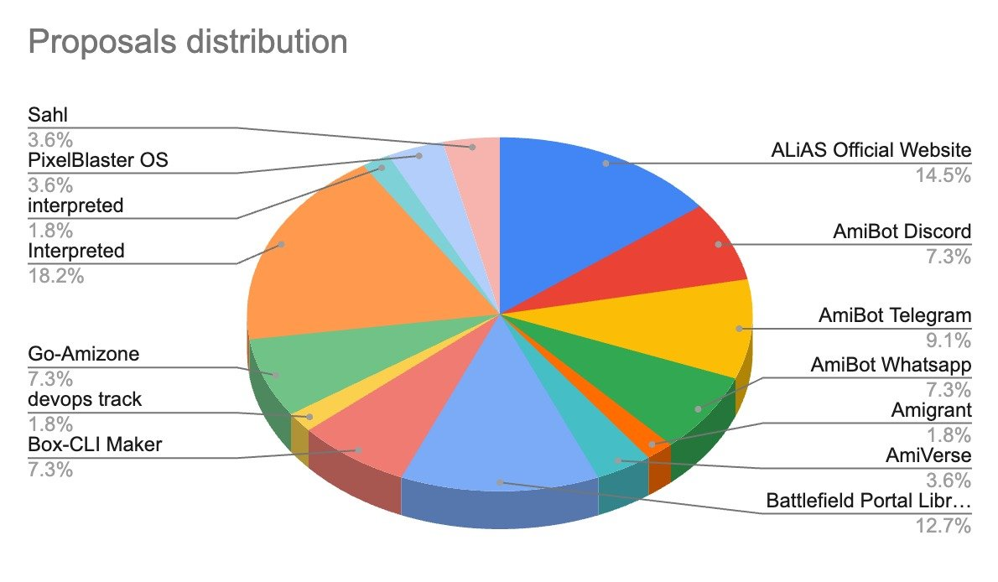

More than 50 students applied for the program, after careful selection and review of the proposals 24 students were selected.

The mentorship occurred over the month of September on the ASoC Discord channels.

Apart from this ASoC also saw a design-a-thon, a contest for ALiAS members where they showed their creativity in creating tshirt and sticker designs for ASoC.

The winning designs were:

|  |  |
| --- | --- |

Made by Rishika Singh, First year Btech Computer science and engineering.

ASoC recieved incredibly positive feedback from the mentors and mentees envolved.

**Media:**

ASoC Logo:

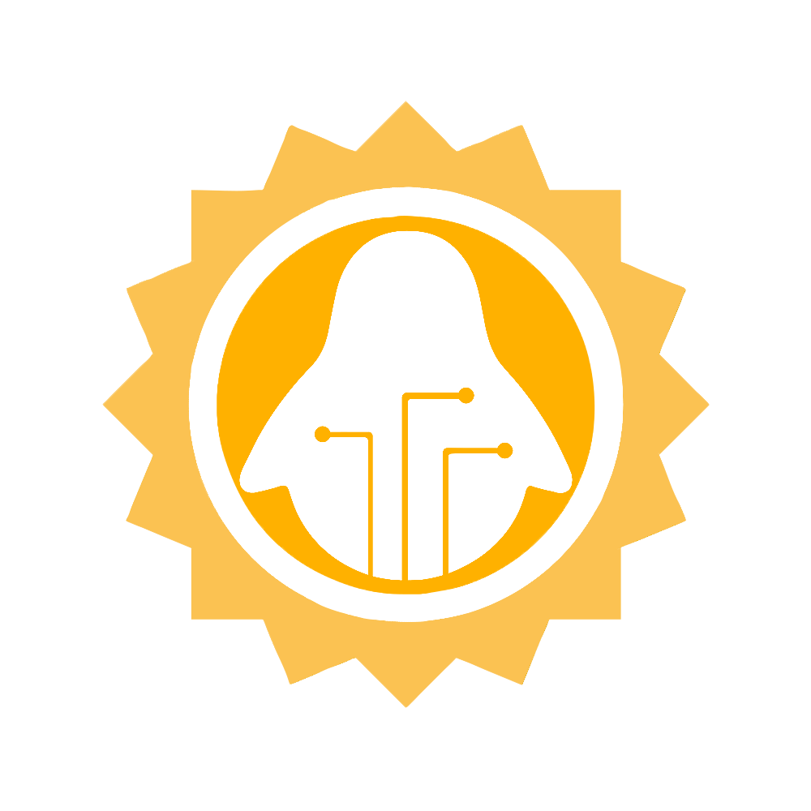

ASoC Posters:

|  |  |
| --- | --- |

ASoC website

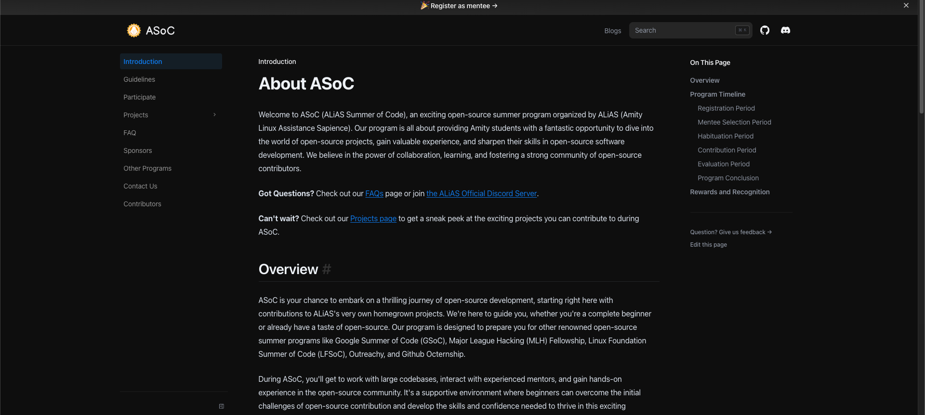

ASoC Discord server:  
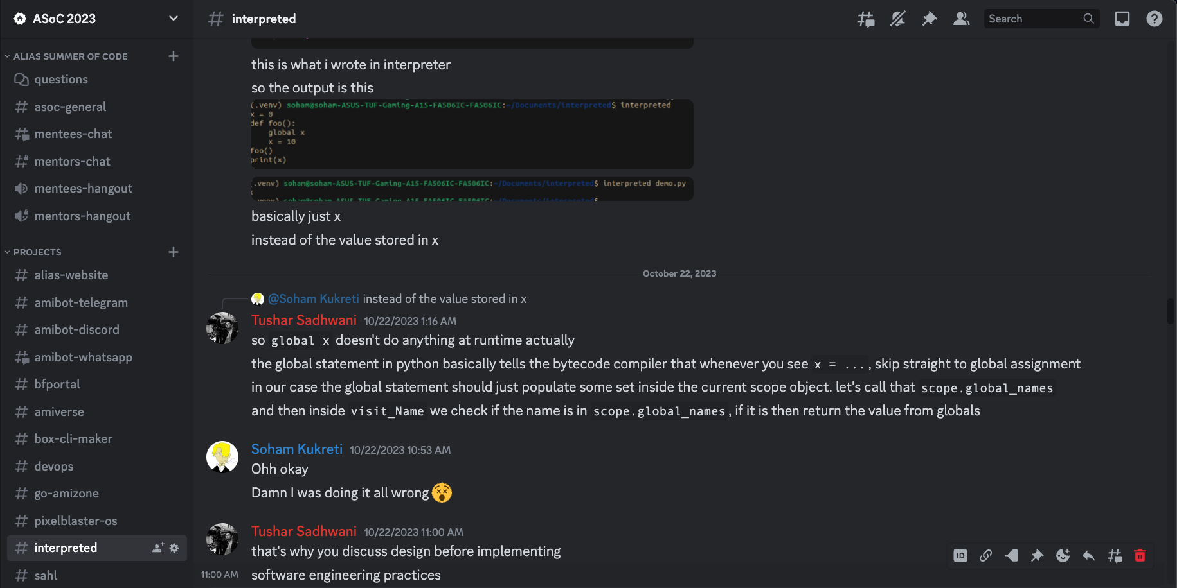

Mentee feedback:

